Top Mentor Assignment - 1

Project Title:
"Screen Time Habits in the Digital Family"

Objective:
To collect and analyse screen time data from family members and identify patterns in usage. The goal is to learn how screen time affects sleep, productivity, and daily habits.

Problem Statement:
"Families are spending more time on screens every day. This project will help you understand how different age groups use screens, how much time they spend, and whether it's affecting their well-being."

Key Findings:

Average Screen time by Age group
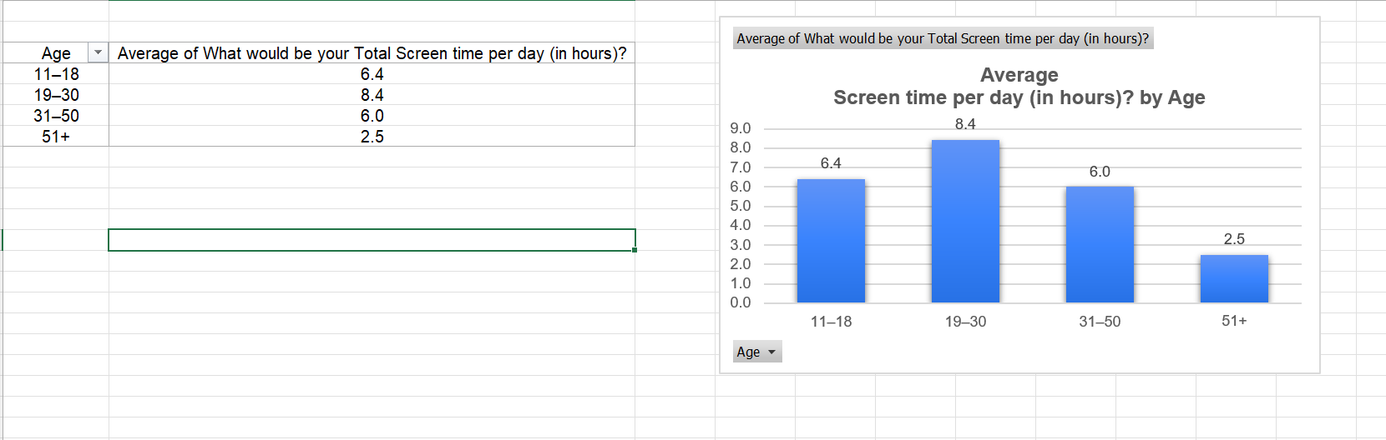
Observation:
- The 19–30 age group recorded the highest average screen time.
- Participants aged 51 years and above had the lowest average screen time.

Work Vs Entertainment Screen time
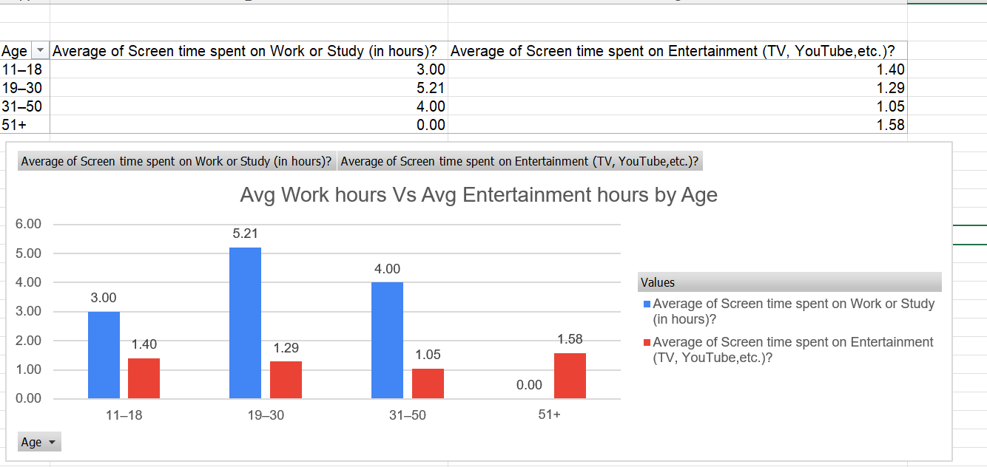
Observation
Most adults primarily use screens for work or study, while entertainment contributes a smaller portion of their daily screen time.

Sleep Affect due to Screen Time
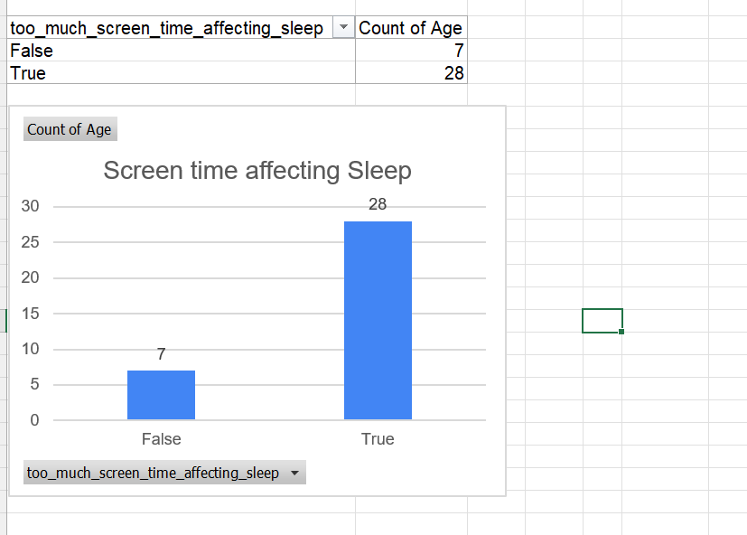
Observation:
People using screens after 9 pm has observed a significant impact on their quality of sleep.

Device Usage
The most commonly used devices were:
- Mobile Phones
- Laptops
Smart TVs were mainly used by older participants, while gaming devices were used less frequently.

Overall Observations
- Young adults (19–30 years) spend the most time on digital devices because of work, higher education, and social media.
- Teenagers mainly use screens for studies, entertainment, and social media.
- Adults aged 31–50 use screens largely for professional purposes.
- Senior citizens have significantly lower screen time and mainly use screens for entertainment or communication.
- Although not everyone reported sleep issues, higher screen time generally corresponded with a greater likelihood of reporting sleep disturbances

Recommendations
- Reduce screen usage at least one hour before bedtime to improve sleep quality.
- Use built-in Screen Time or Digital Wellbeing features on devices to monitor and manage daily usage.
- Encourage regular breaks from screens by following practices such as the 20-20-20 rule (every 20 minutes, look at something 20 feet away for 20 seconds).
- Promote screen-free family activities such as outdoor games, reading, exercising, or spending quality time together.

